**WEEK 8**

1. **Git HOL**

The hands on given in this document is done and stored in the folder named   
**2. Git log file**

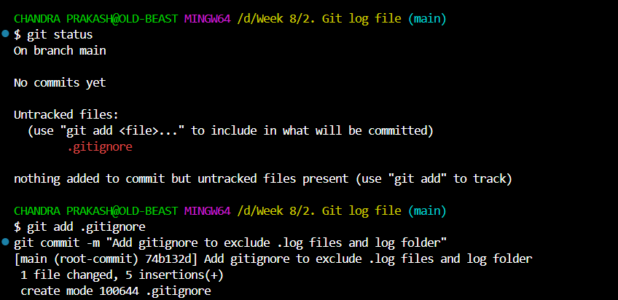

Here git ignores all the .log and log files successfully   
hence gitignore works perfectly